**Lab 40**

**Self-Practice Solution: Creating VNet on Azure​ in Indian Subcontinent**

**Task: Create a VNet on Azure​**

***Sign in to Azure***

Sign in to the Azure portal.

***Create a virtual network***

1. Select **create a resource** in the upper left-hand corner of the portal.
2. In the search box, enter **Virtual Network**. Select **Virtual Network** in the search results.
3. In the **Virtual Network** page, select **Create**.
4. In **Create virtual network**, enter or select this information in the **Basics** tab:

|  |  |
| --- | --- |
| **TABLE** | |
| **Setting** | **Value** |
| **Project details** |  |
| Subscription | Select your subscription. |
| Resource group | Select **Create new**.  Enter **myResourceGroup**.  Select **OK**. |
| **Instance details** |  |
| Name | Enter **myVNet**. |
| Region | Select **Central India**. |

1. Select the **IP Addresses** tab, or select the **Next: IP Addresses** button at the bottom of the page.
2. In **IPv4 address space**, select the existing address space and change it to **10.1.0.0/16**.
3. Select **+ Add subnet**, then enter **MySubnet** for **Subnet name** and **10.1.0.0/24** for **Subnet address range**.
4. Select **Add**.
5. Select the **Security** tab, or select the **Next: Security** button at the bottom of the page.

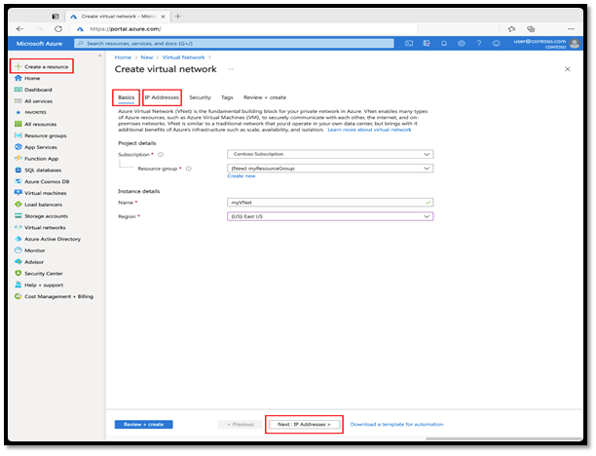

1. Under **BastionHost**, select **Enable**. Enter this information:

|  |  |
| --- | --- |
| **TABLE** | |
| **Setting** | **Value** |
| Bastion name | Enter **myBastionHost** |
| AzureBastionSubnet address space | Enter **10.1.1.0/24** |
| Public IP Address | Select **Create new**.  For **Name**,enter **myBastionIP**.  Select **OK**. |

1. Select the **Review + create** tab or select the **Review + create** button.
2. Select **Create**.